**Ideation Phase**

**Brainstorm&Idea Prioritization**

|  |  |
| --- | --- |
| Date | 06th November 2022 |
| Team ID | PNT2022TMID53593 |
| Project Name | Real-time River Water Monitoring and Control System |
| Maximum Marks | 4 Marks |

**Step-1: Team Gathering, Collaboration and Select the Problem Statement**

**Step-2: Brainstorm, Idea Listing and Grouping**

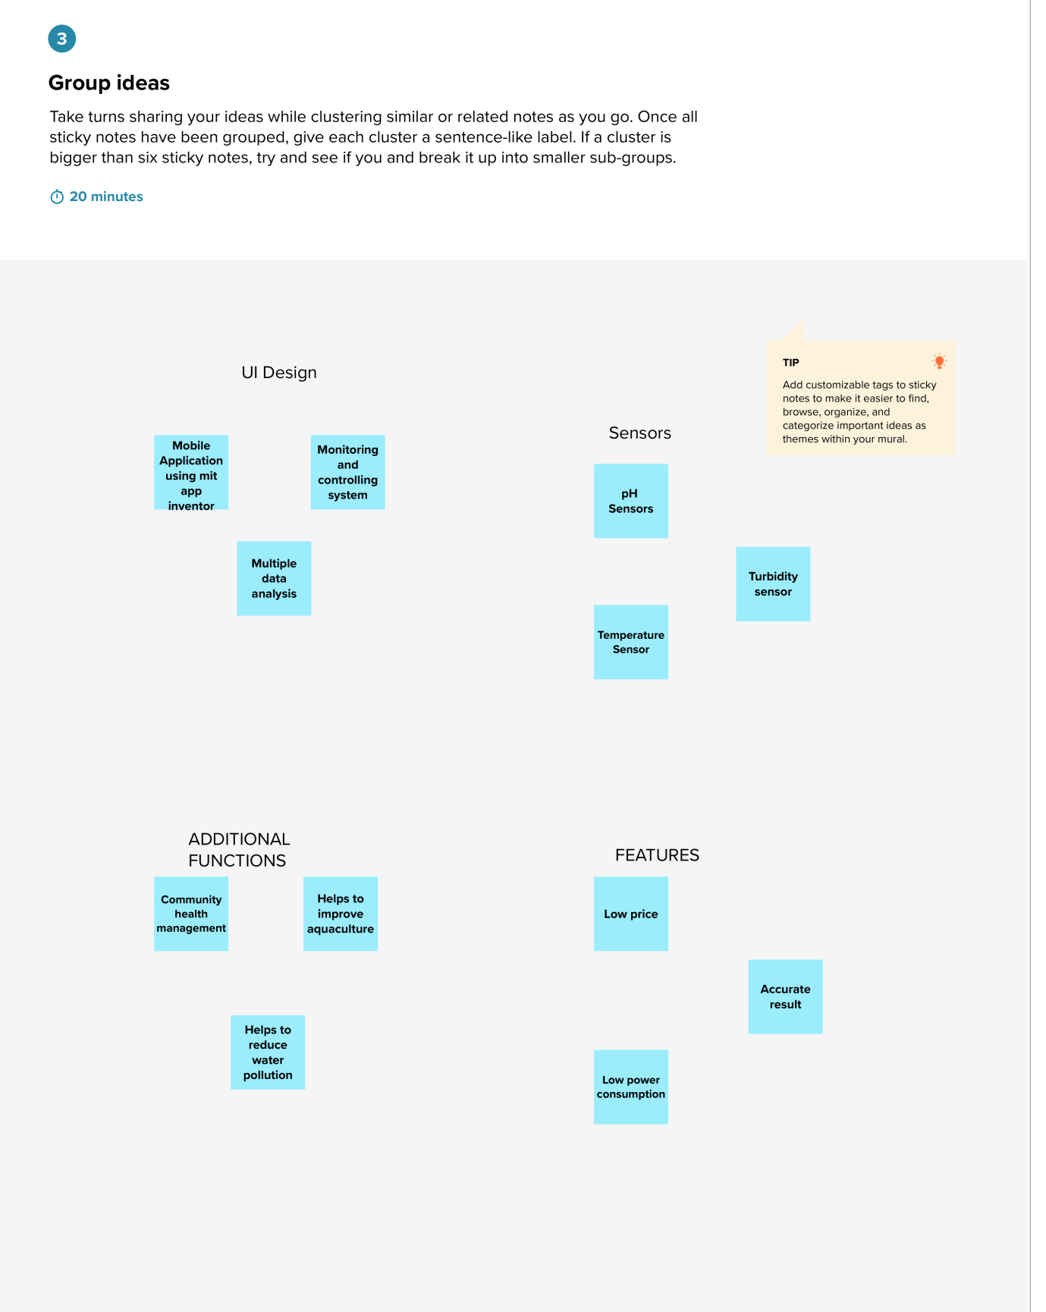

**Step-3: Idea Prioritization**

